Looking back at 2013 for FVRC members.
2013 has at last given us a wonderful summer of weather and for Finn Valley it has been another very successful year. Even with a low membership numbers compared to some clubs we have had many successes on a National Level as well as locally. The training sessions have been well attended and regularly held at Orwell Arena with Jonathon and Tammy, as well as XC training at Poplar Park. The ODE in June was a great success and even with Area 8 joining us we managed to fit everyone in before it got dark. The Annual show, although slightly down on entries, was another successful show.
Some highlights of 2013
- Junior team 8th at Winter Dressage Championships at Hartpury. Isabella Stagg 5th and Shirley Stagg 6th
- Isabella Stagg 2nd at the Festival Of The Hunter qualifier at Geldeston
- Julia Sheppard 9th at the Royal Windsor Top score
- Senior team 4th at Area Dressage qualifier. Isabella Stagg 1st and 2nd and Shirley Stagg 1st both qualifying for Nationals. Caroline Steward came 6th, Krystina Fish came 7th and 6th in the Novice RT. The senior team came 4th.
- Senior Novice team 2nd at Area Horse Trials. Isabella Stagg 1st in Junior 100 and Shirley Stagg 1st in Senior 100+
- Isabella Stagg 5th in Junior 100 at National Horse Trials Championships
- Senior Intermediate Show Jumping team NATIONAL CHAMPIONS at NAF National Championships.
- Shirley Stagg finishing 11th in both Novice dressage tests and Isabella Stagg in the Junior Intermediate show jumping, sadly just rolling a pole in both rounds at NAF National Championships

Training Dates

- Flat work with Tammy Ruffles 21st September
- Jumping/pole work with Jonathan Allinson 21st September, 26th October, 30th November, 14th December

Please contact Krystina Fish to take part 07525020417 krystina3@fsmail.net

FVRC WEBSITE IS A GREAT SOURCE FOR UPTO DATE INFORMATION, TAKE A LOOK @ WWW.FINNVALLEYRIDINGCLUB.COM

YOU CAN ALSO FIND US ON FACEBOOK

Dates for your diary 2013/14

AGM
10th October at Fynn Valley Golf Club
7.30pm

LDR 27th October Tunstall
RWHS Top Score qualifier 24th November at Wix
Indoor winter dressage 30th – 1st December
Area 14 Novice Show jumping SJ 23rd February at Wix
Hartpury Winter Champs 29th and 30th March
Eventer Trial (FOTH) 13th April Thorne Court
Combined training date TBC
Area Horse trials 22nd June at Poplar
Area SJ TBC
Area Dressage TBC

If you wish to be part of the team or individual contact Barbara on john.j.s.smith@btinternet.com

If anyone has any news or photographs or any information or stories they wish to be included in the next newsletter, then please email to me at bellalewendon@gmail.com

National Horse Trials Championships 2-4th August
by Shirley Stagg
My sister Isabella and I were very happy to have qualified to go to the Horse Trials Championships at Swalcliff, near Banbury in Oxfordshire. The qualifier was run by Finn Valley in June. We travelled up on Thursday on the hottest day of the year, and typically got stuck in a traffic jam on the M25! Nothing too serious, and despite the horses looking rather hot they coped extremely well. I qualified for the Senior 100+ and had my trot up and vet inspection first thing. I had never done a trot up before and although I had practiced it, I forgot to practice with two pots of flowers which Twix, my horse, thought were very exciting and were definitely harbouring a gremlin in them! We passed that and then had the dressage which went fairly well and I was pleased with his test. Isabella just rode out that day as her competition started on Saturday.
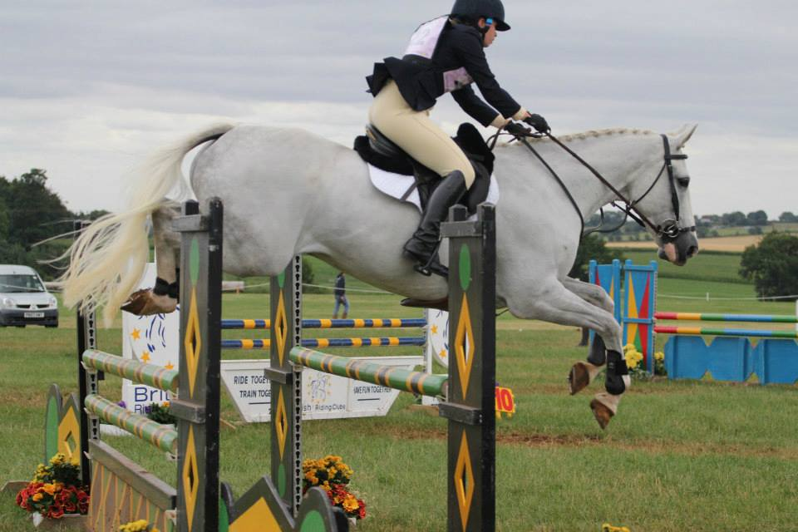
Roads and tracks with the steeplechase came first, which was incredibly good fun. All went well and I trotted in to the ten minute box to meet my ground crew (my mother) with her wheel barrow full of buckets, studs, reins, gloves, grease and drinks for me and Twix. We passed the vets inspection and then set off for the x-country. This seemed a very challenging course with some difficult combinations, but actually rode really well. Unfortunately, Twix took a disliking to the wooden fish jump in the water, and nearly took the photographer, the fence judge and camera man on a stand out trying to avoid it. Success in jumping it on the second attempt, and all went very well after that. The next day, we had the early morning trot up and there were some very nervous people madly trotting up their horses to check for lameness. Some people were unlucky and couldn’t continue, but Twix was fine and full of beans!
The show jumping in the afternoon was quite influential to the final scores. We unfortunately had the first fence down but then he jumped really well around the rest of the course. We even got our picture on to the BRC gallery from the horse trials over a big oxer. Such Fun! We finished 20th in our arena and although I would have liked to have done a little better, it was an amazing experience and one that I would very much like to do again. Isabella had a two day competition in the Junior 100 with her dressage and show jumping on the same day as my cross country. Mother’s wheelbarrow was still in action until late afternoon! Isabella did a lovely dressage and went clear over the show jumps.
She also had to do the roads, tracks and steeplechase, and she had never used a stopwatch during a competition before. We wrote all her times up her arm and fortunately she rode in short sleeves! Tia set off very well and they kept to all their times and arrived at the ten minute box in plenty of time. Her course was also very challenging and with Tia being 17 years old, we were a little worried about all the hills and change of terrain. She coped incredibly well and finished clear well within the time. Isabella was so pleased with her and was rewarded with a 5th place.
We would both like to thank the Club for their tremendous support before and during the Championships and hope that we and some other members can qualify next year.

BRC Topscore Finals at Windsor Horse Show 10th May
By Julia Sheppard
I was lucky enough to qualify for the BRC Topscore final at the Windsor Horse show. We had a great day and enjoyed watching some top riders showing us how it was done earlier in the day! Having been drawn 4th out of 40 in the class we were at a big disadvantage as only had 5 minutes to walk the course and then come up with a route to maximise points. I decided to get the 200 point joker in twice early on and then see what happened from there! We finished on a score of 1490 and were in the lead for a while. Some fast horses followed and eventually we finished 9th in a strong field but we had a great day!

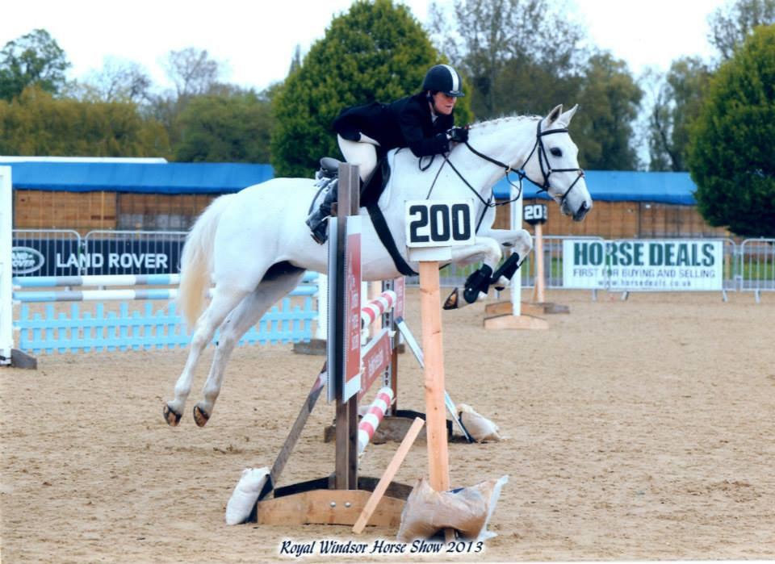

NAF National Championships

The Senior Intermediate SJ team travelled to Lincoln for the Championships. The team of Julia Sheppard, Shirley Stagg, Rosie Stevens and Amy Curl had a great chance at the final but even surprised themselves when they won. Having finished on a score of zero after the first round along with only 3 other clubs, the second round would separate out the teams. The jumps were raised and the poles went flying! Rosie set off with a great clear with Van Neolux, Julia and Hot Prospect sadly rolled a few poles so it was down to Amy on Rough Diamond and Shirley on Possibilities! The pressure was on but despite this they both managed great rounds with just 4f each. So we completed on a total of 8f. After a long day the results were announced and convinced a team would be on a lower score we were surprised to be announced the SENIOR INTERMEDIATE SJ CHAMPIONS

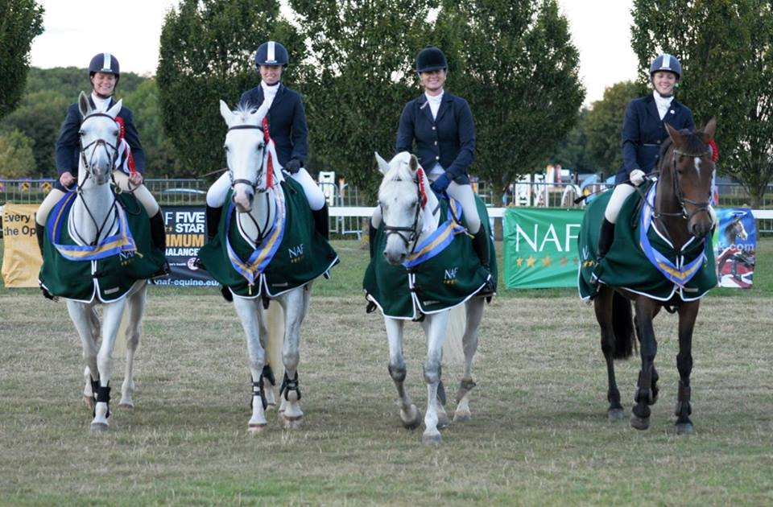

Isabella Stagg competed in the Junior Intermediate Area 14 team on the Sunday and jumped great round just lowering a pole in each round. Shirley finished just out of the placings in the Open Dressage in 11th place in both arenas. A great experience for all, well done Finn Valley!

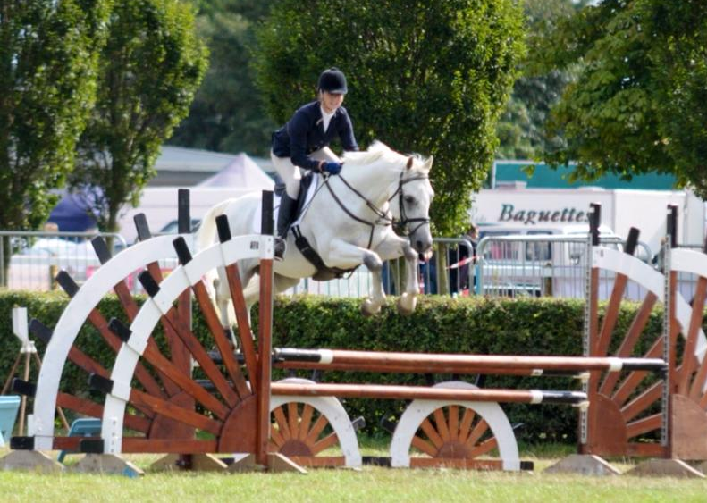

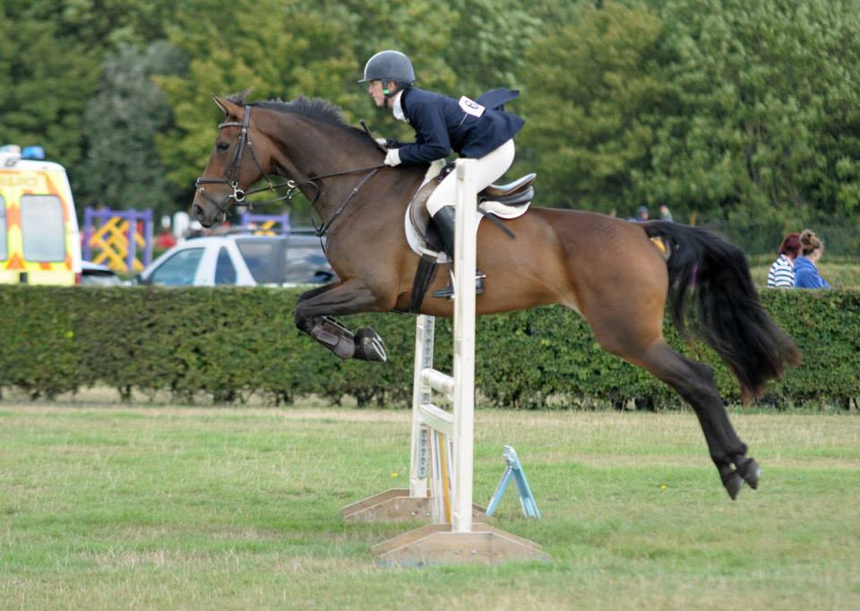

Trailblazers and UK Riders

Although not BRC events Krystina Fish completing at both Championships on her chestnut gelding Leudo. Having to learn several different tests at both championships is a great challenge in itself but to come home with 2nd place is fantastic. Maybe the rum and coke for breakfast helps! A great achievement, well done!
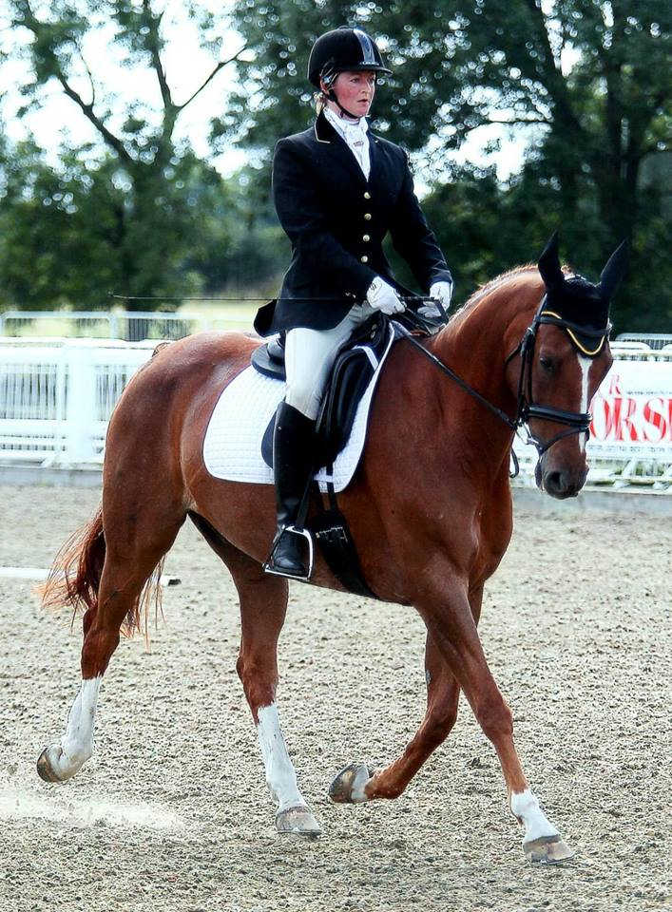

Beach Ride

On Sunday 22nd September several members made the long trip up to Holkham for a great ride along the beach. A fantastic day was had by all and even Julia entertained everyone with an unplanned deep sea swim!

Some pictures form the day thanks to Gordon for coming to take photos!

