NEWSLETTER JUNE 2012

Welcome FVRC members, hope you and your horses are well and managing to get out and ride and compete in this unpredictable weather!

Committee members have been busy putting the final touches to the organizing of the Area ODE, a change of venue had to be made from the usual Poplar Park to Great Witchingham Norfolk, so hope to see some of you there competing with your horses or helping on the day.
We would love to hear more from our members, so if you would like to keep us updated with show/qualifier reports or just about yourself and your pony/horse send some information and photos please to rosemary.stevens632@btinternet.com

New Training Dates
These are open to members and non-members
Jonathan Allinson pole work Tammy Ruffles Flat work
1st July: pole 15th July: flat
21st July pole 25th August flat
29th September pole 15th September flat
20th October pole 13 October flat
Please contact Krystina Fish on 07525 020417 or Krystina3@fsmail.net if you would like to be involved in training.

Area 14 Camp 25-26th August 2012
VENUE GT WITCHINGHAM – Open to all Area 14 over 12 years of age
For more Info go to www.area14brc.org.uk

Houghton Dressage Reported by Krystina Fish
Nic Peek and I had a go at the Pairs test. Unfortunately there was a lot going on at the time and a number of horses were unsettled so we had some trouble and it did feel disapointing that we couldn't show everyone how hard we had worked over the previous month. We had really enjoyed our practising sessions at Nic's lovely home, and riding to match each others pace and transitions really pointed out our areas to personally work on which I have definitely found has helped me with my own riding! We will have another go next year! :-)
The senior team were Julia Sheppard, Nic Peek, Stephen Wombwell and me. I placed 9th and Julia 11th individually :-) The team sadly didn't place BUT we all REALLY enjoyed the whole event. Due to the massive 3DE going on around us at the same time it was really amazing to be warming up surrounded by professional riders competing for their place in the Olympic Team!! We were all a bit star struck!

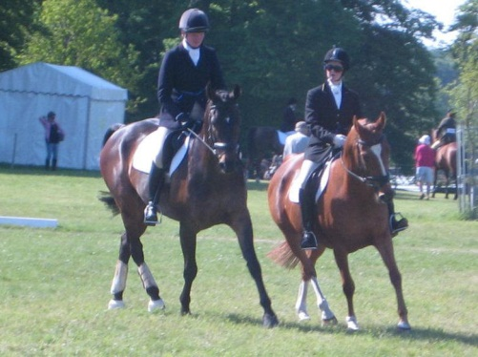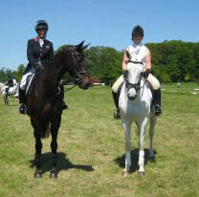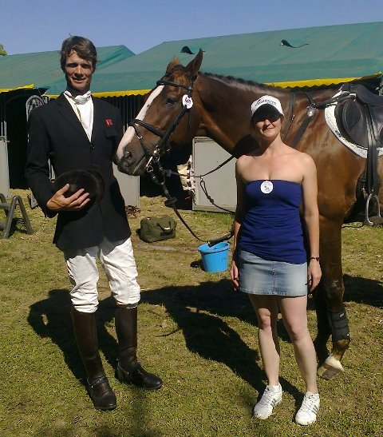
Nic & Krystina Mary King & Julia William Fox-Pitt & Krystina

FUTURE EVENTS
Area Dressage Jnr & Snr Stratford Hills 8th July
Area Show Jumping Jnr & Snr Geldeston Hall 22nd July
If you would like to take part in these please contact Barbara 07772 204313

KRYSTINA FISH & LUEDO MAKE THE FRONT COVER OF BRC RIDER MAGAZINE
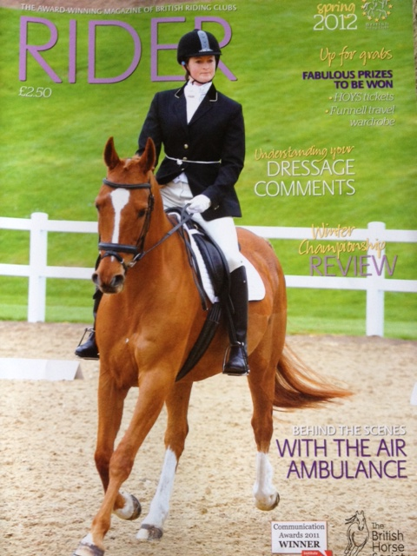 COMPETING AT HARTPURY BRC CHAMPIONSHIPS

How has FVRC helped you?.... Annabel Brown
I joined the club in 2000. A few weeks after I joined, Nicky Steward, who at that time was team organiser, invited me to join a team for a hunter trial at Boundary Farm. I didn't tell her that up till now all Leo and I had done competitively was endurance rides, which being half Arab he absolutely loved. Neither of us had ever been on a cross country course even to practice. So along came the day of the competition. We set off and Leo was very happy and forward going, clearly assuming he was on an endurance ride. Suddenly, whoops, there was a log in front of him. Shock! He stopped dead. We turned, had another go and sailed over it. Same again at the next obstacle, then again, and then suddenly, the light came on and he flew round the rest of the course with great gusto, not putting a foot wrong. Nicky told me afterwards she could see the whole thing and the moment when the penny dropped. By that time we had been eliminated so I was quite embarrassed to get a rosette for 4th place thanks to the efforts of the other team members. Since then we have enjoyed many a hunter trial, coming first once! So thank you Nicky for giving me the chance, and the moral of the story is, give it a go!
Annabel Brown

FVRC website is updated regulary so please check it out for updates, news, reports and photos.

