Spring 2016

FVRC website is a great source for up to date information
www.finnvalleyridingclub.com
You can also find us on Facebook

Chairman James Smith
jameswsmith1977@gmail.com
07778654541
Secretary Barbara Smith
john.j.s.smith@btinternet.com
01728 685369

Dates for your diary

24th July Area SJ and Style SJ at Geldeston
31st July Team of three SJ on at Hickstead
5-7th August Horse Trials Championships At Swalcliffe
27th August Summer BBQ at Newbourne
10th-11th September Lincoln National Championships
23rd October Long Distance Ride at Rendlesham

Area SJ

The Area SJ is being held at Geldeston on 24th July. This is a qualifier for Lincoln on the 10-11th September. There are three heights available for Juniors and Seniors. For the first time this year Juniors can jump in the Open class as mixed teams with Seniors. Each rider will jump two rounds and if equal faults a third jump off round.

Novice Team & Individual max height in first round 80cm
Intermediate Team & Individual max height in first round 95cm
Open Team and Individual max height in first round 110cm

Alongside the team SJ there is the Style Jumping for both senior and junior riders. It is open to teams and individuals. Each team consists of two riders jumping a 75cm course and two riders jumping an 85cm course. Individuals may choose. Riders jump one round and are judged on the style of their riding. Riders must salute the judge when entering the arena, and then canter a figure of eight until the signal to start is given; during this time, they will be judged for style on the flat. When jumping, the rider is judged on how they ride the whole course, particular attention being given to how they ride the turns and present the horse at a fence. The rider needs to show balanced approaches to the fences and be able to maintain a good forward canter in rhythm. The position of the rider at take-off, in the air, on landing and in the following strides is assessed along with the correct judgement of pace.

If you would like to enter either the SJ and/or Style Jumping please let me know. Fee per class is £15 and entries close on the 9th July.

Julia
juliasheppard99@hotmail.co.uk

Club Kit

Club kit is available from our brochure. If you would like to order please email Cress at b_callman@hotmail.com

Summer BBQ

Date for the Summer BBQ will be the 27th August. Please all keep this date free for more inflatable fun! The tickets will be £5 per person and under 10s will be free.

Long Distance Ride

Another successful Long Distance Ride for Finn Valley RC on the 20th March in Rendelsham Forest with 45 riders, slightly down on the last one. Nine of those were members.

The morning started dry with some sunshine and as the riders arrived they set off over the 12 mile route through lovely countryside marked out by James who went round in the morning on his bike with his can of marker spray.

All of the riders came back and said what a lovely ride it was and looking forward to the next one later in the year. At the end of their ride they all had their cup of soup and a roll, and also went home with a rosette. We only lost two or three riders but they did make it back after a while!!

It was nice to see members from the club riding. Thanks also must go to Jacquie, Colin and Gordon for doing the check points and for Cress marking them off when they leave and checking them in on their return, especially as she was about to go on holiday and should have been packing! A big thank you to Anne Corke for the lovely soup and especially to James for marking the course.

Hope to see you again at the next ride.

Winter Championships

We had four riders at the Winter Dressage Championships this year. Kirsty Dawes and Daisy Kiddy were at Keysoe for the Novice Dressage and Shirley Stagg and Natalie Flewitt at the Intermediate Dressage at Bury Farm. Everyone had a great time representing the club at Championship level. Velvet and Daisy did a very good test against stiff competition to come 12th, scores were very close and only a few percent between fifth and 12th. Kirsty came 5th in another close arena with 2nd place only got 0.6% more. Natalie picked up 4th place and Shirley had a great time but sadly just finished out of the placings. Well done to all of the riders!

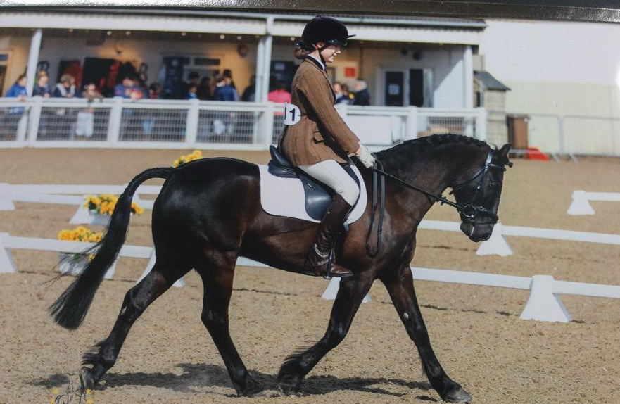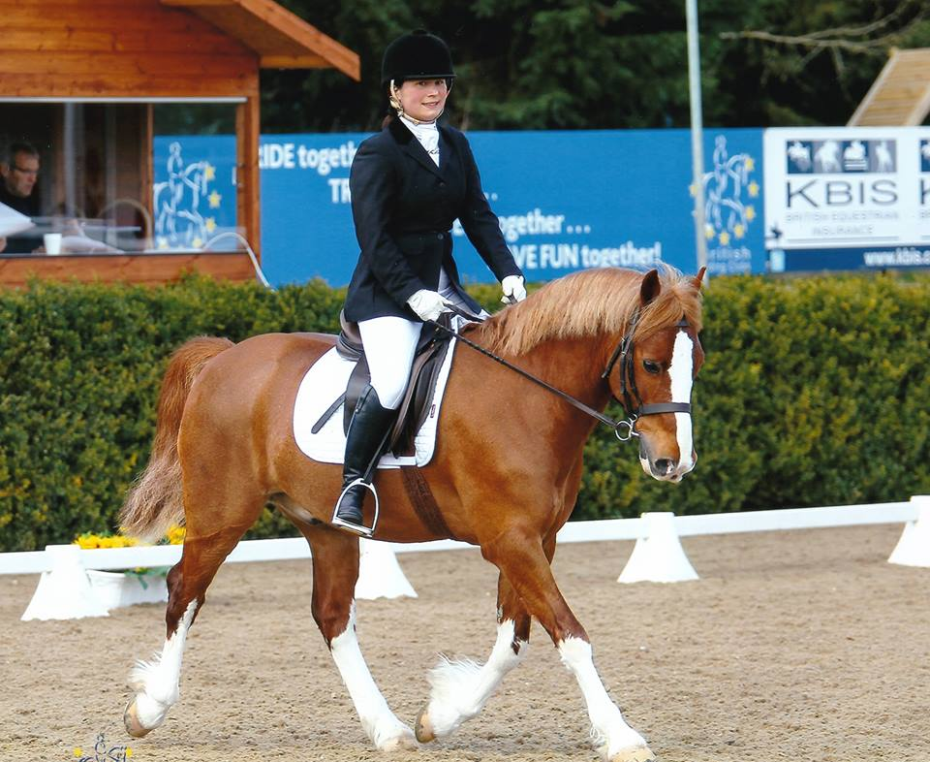

Daisy Kiddy Kirsty Dawes

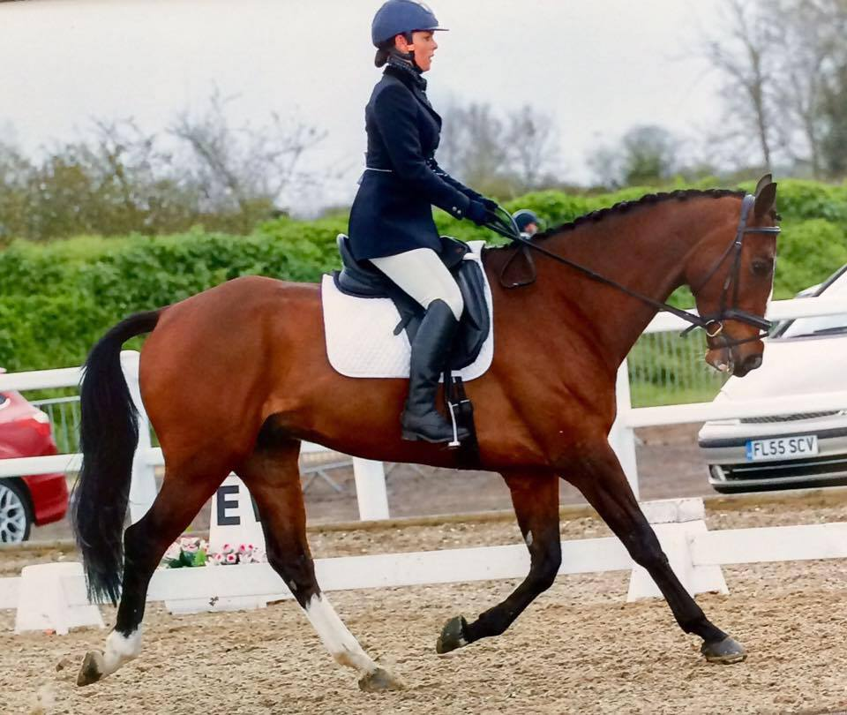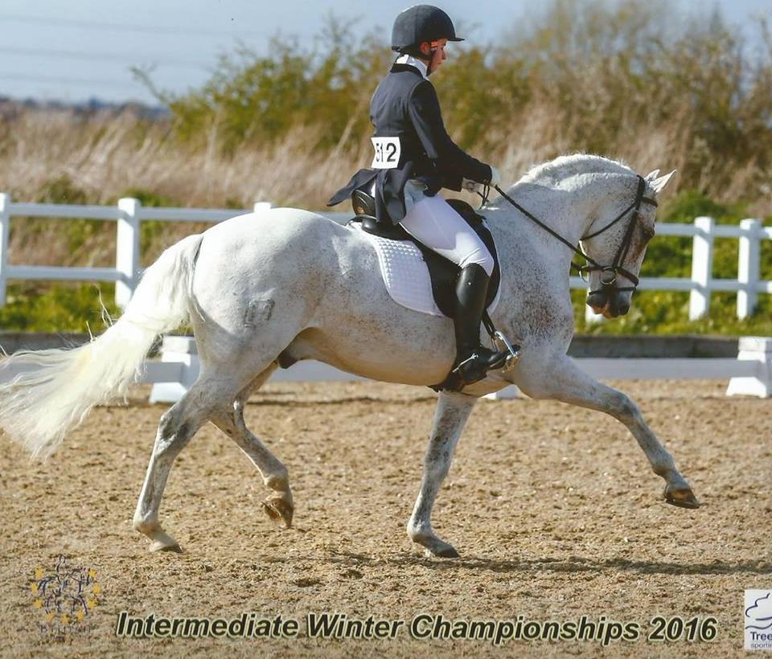

Natalie Flewitt Shirley Stagg

Area Combined Training

On Sunday 24th April we set off to the Combined Training at Thorn Court, run by St. Edmunds RC, it was a really cold day and we even had sleet but Finn Valley are tough and didn’t worry about the weather. We had two senior teams Jenny James, Ruth Everard, Kirsty Dawes & Joe Mace in team B and Jess and Joe Mace, Julia Hicks, Danielle Noble in team A, plus Luisa Edwardes riding as an individual.

For the Juniors we only unfortunately had a team of three, Lauren Hassan, Shannon Curtis & Imogen Hughes. Everyone did good dressage tests and only a few show jumping penalties as well as some lovely clear rounds. It was difficult for the juniors only have 3 riders but they all did good dressage tests and Lauran and Shannon went clear show jumping, it unfortunately was not Imogen’s day in the show jumping ring missing a fence! Lauren won her section and qualified and Shannon finished 2nd.

There seemed to be a long wait until results were finalised. Sadly we did not hear on the day but results were posted in the week and our Novice B team has won and qualified. Jenny James coming 2nd, Kirsty Dawes 3rd, Joe Mace 6th and Luisa Edwardes 9th. We also had Kelly Jarrett and Jill Pass riding as non-qualifiers both enjoying their experience.

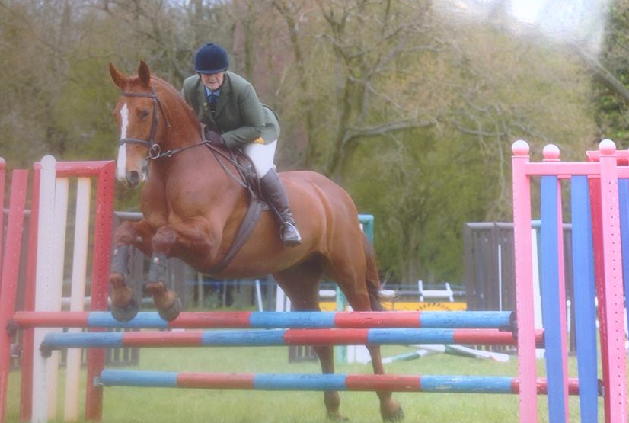

Ruth Everard

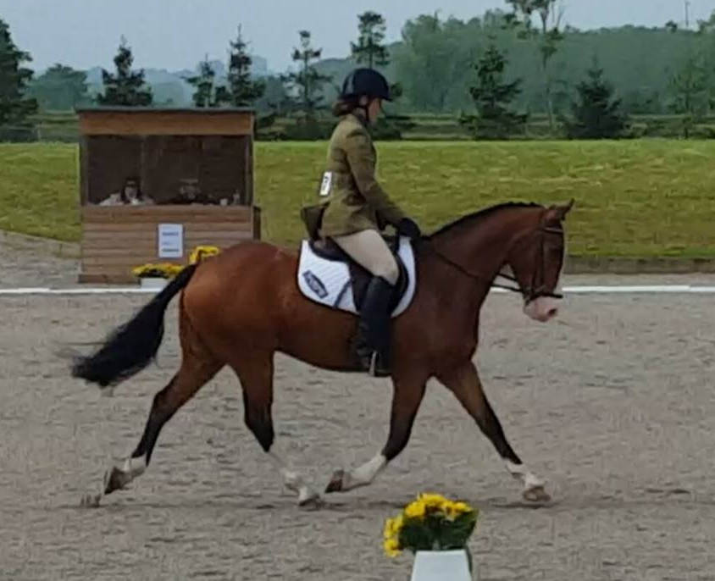

Jenny James

Area Eventer Trial

On May 14th was the rescheduled Eventer Trial run by Area 8 at Stratford Hills, it was a cold day but at least it was dry.

First to go on the day was April Brown doing the 100 cm as an individual she had a great round and won the class. Next was the Senior 90 team, Joe Mace was first to go followed by Rosie Stevens, James Smith and finally Emma Sayer; all went double clear with Joe just having a few issues XC on his inexperienced horse. The team went on to win the class!

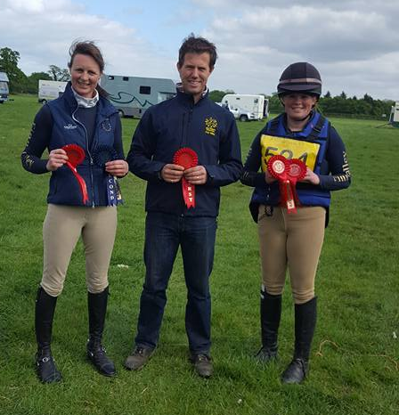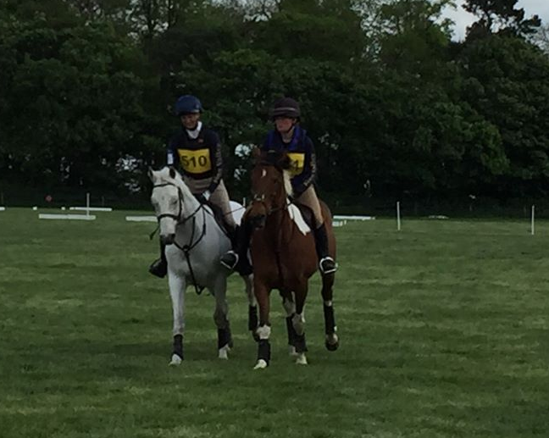

Senior Team Emma & Rosie

It was then the turn of the 90cm pairs and Emma and Rosie were off again they had great rounds and both went double clear, finding out later that they had also won.

We had two juniors doing the 90cm Annabel Long and Shannon Curtis. Both rode really well and had good rounds Annabel coming 2nd and Shannon 8th. We later found out that as the winner was in the winning team so Annabel had qualified. Another good day for Finn Valley.

Area Dressage

Back to Stratford Hills on May 15th for the Area Dressage organised by Deben Riding Club, it was much warmer today but the ground was fantastic.

We had two Senior Prelim teams Ruth Everard coming 12th, Danielle Noble 14th, Luisa Edwards 1st and Molly Appleby 13th in team Yellow. In team Green we had Joe Mace coming 2nd, Jess Mace 3rd, Kelly Jarrett 13th and Kirsty Dawes 1st.

In the Riding test team we had Kelly Jarrett 15th, Luisa Edwardes 3rd, Jess Mace 11th and Joe Mace 21st. All riders did good tests but the standard was very high. When the scores did finally get put up we were delighted to hear that the Senior team Green had won.

For the Juniors we had a junior team consisting of Tabby Wade who came 6th, Dulcie Wade 1st, Shannon Curtis 2nd and Lauren Hassan 5th, same riders did the Riding test and Tabby came 2nd, Shannon 3rd, Dulcie 3rd and Lauren 1st. Lauren Hassan and Paige Fleming also did prelim tests as individuals Paige coming 6th. We later found out that they had won the Riding Test team and are heading off to Lincoln again!

We had a Senior Open team consisting of Danielle who came 13th in the N24, Shirley Stagg in the N27, Isabella Stagg winning the E43 and Becky De Bree coming 5th in the N28. The standard was again very high they did lovely tests and came 5th as a team.

We had several individuals Shirley Stagg doing M69 & E43 came 14th, Julia Hicks came13th in the N27, Becky De Bree 13th in the E43, Krystina Fish in the N24 came 4th, Jacky Lambert N27 and N24 came 5th. Isabella Stagg had a great day and won both her tests. Well done to everyone – great weekend for the Finn Valley riders.

Houghton Hall 29th May

On the 20th May we sent a team up to Houghton for the team dressage. Despite not getting placed as a team, Natalie picked up a 10th in her first Elementary so a big well done to her! The standard was high but everyone appreciated warming up with the pros!

P7 (2002) Jess Mace IND 66.75% 11th

Team
P7 (2002) Joe Mace 63%
N34 (2009) Shannon Curtis 61.25%
N22 (2007) Lauren Hassan 62.41%
E45 (2010) Natalie Flewitt 57.07% 10th

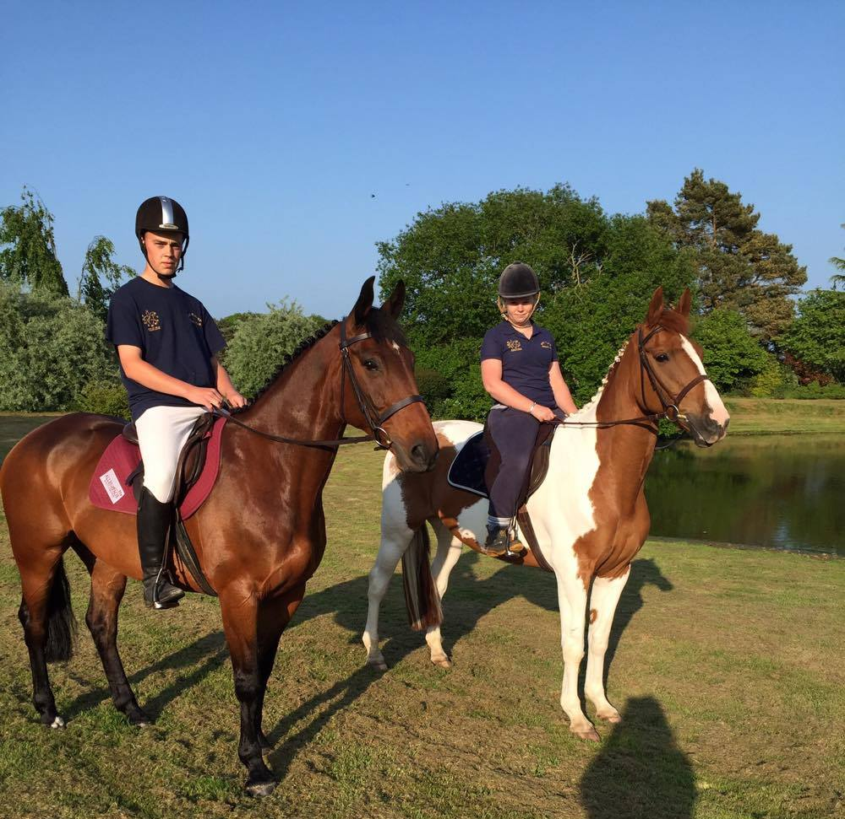

Jess and Joe Mace

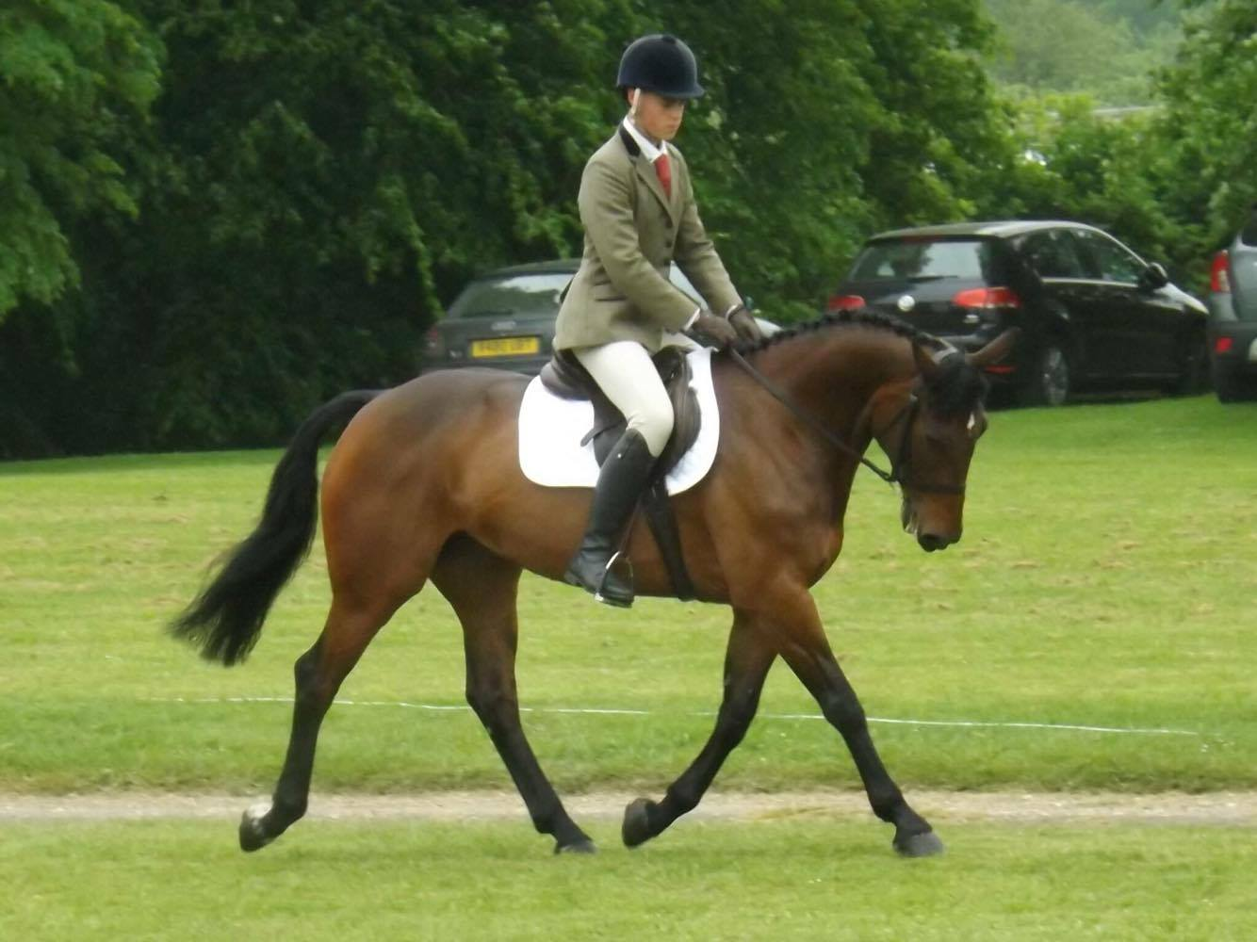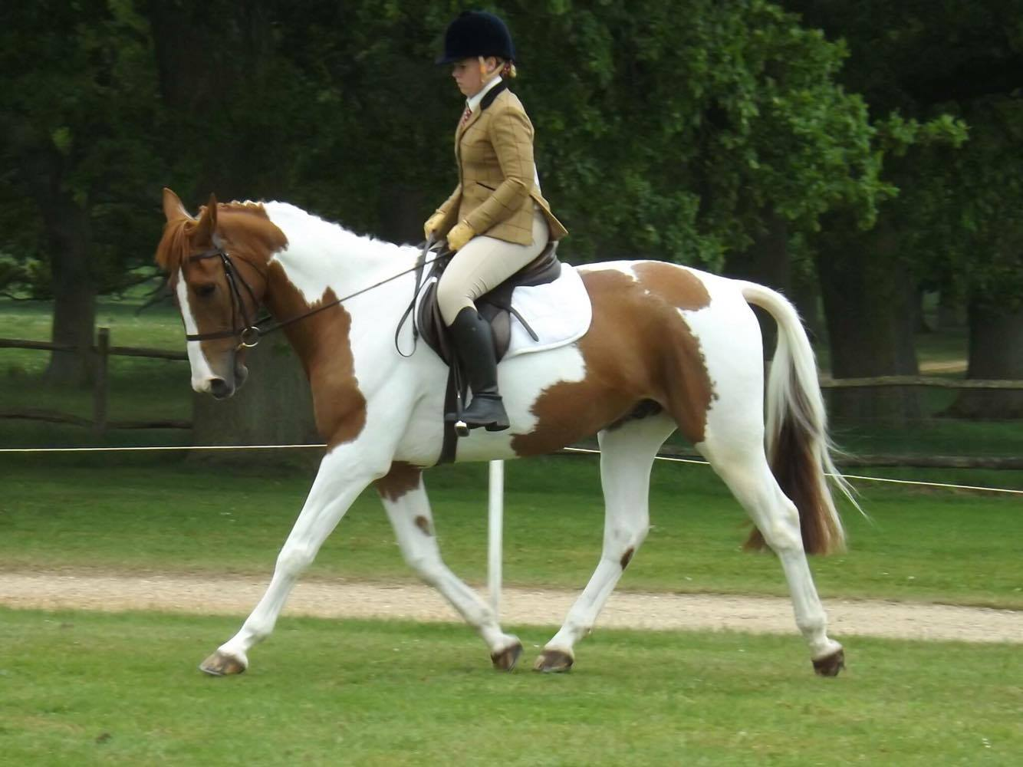

Joe Mace Jess Mace

FOTH Championships

Over the weekend of the 4-5th June we had a busy weekend at Aston Le Walls. We had a Senior Combined Training team (Ruth Everard, Jess Mace, Joe Mace and Jenny James) and Senior Eventer Challenge team (Rosie Stevens, Joe Mace, Emma Sayer and Natalie Flewitt) in action; Emma and Rosie in the Senior Eventer Challenge Pairs and Lauren Hassan in the Junior Combined Training and Annabel Long in the Junior Eventer Challenge; both as Individuals.

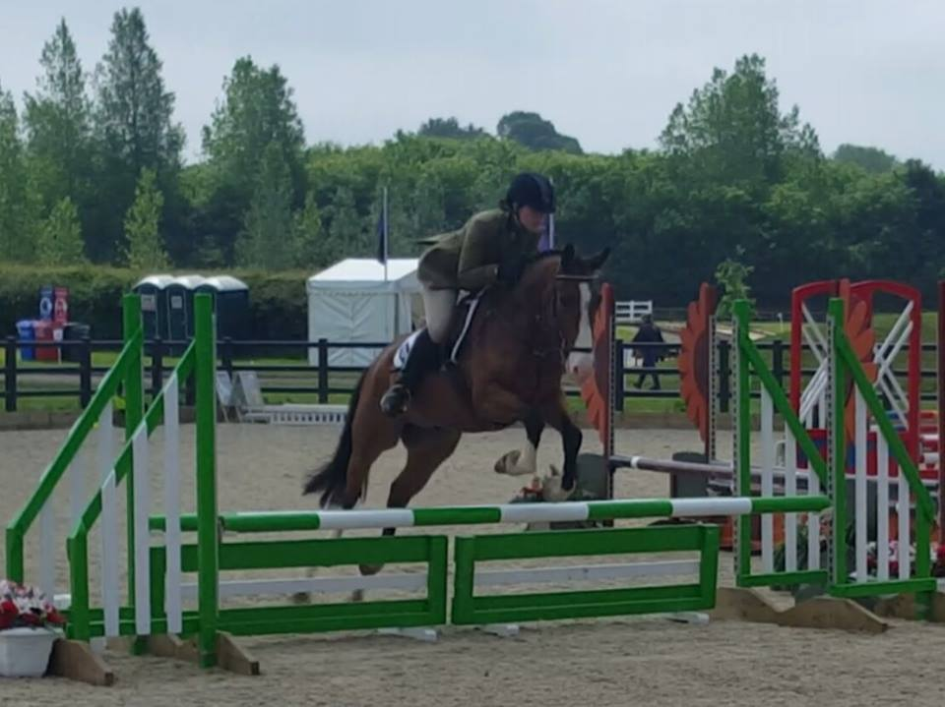

Jenny James

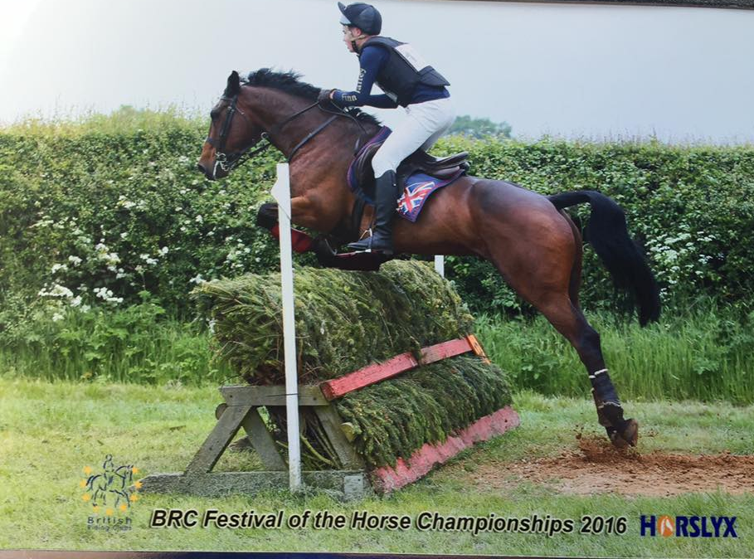

Joe Mace

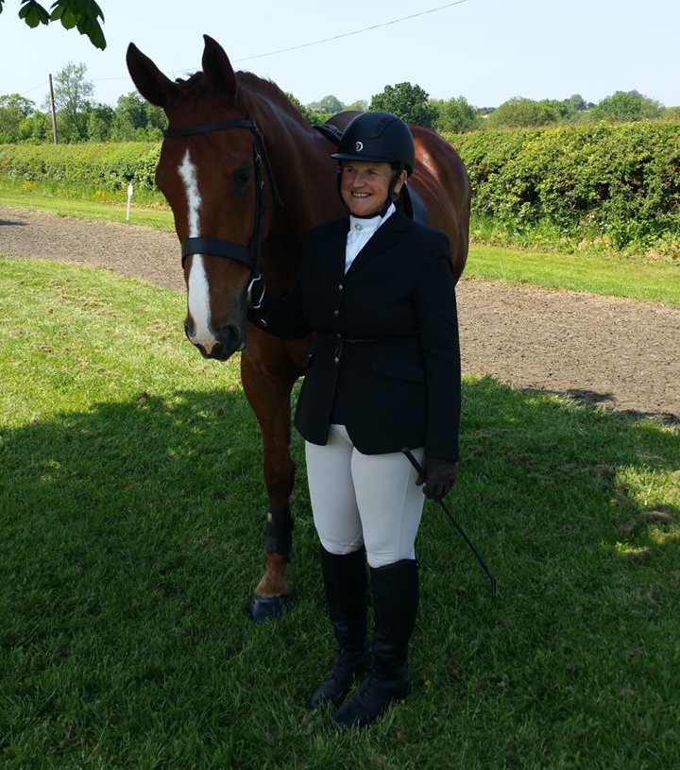

Ruth Everard

Both teams finished outside of the placings with a few time penalties but Jenny James and her youngster Billy Rocket came 5th in their Area. Both Annabel and Lauren lowering one pole each. However, extra congratulations must go to Emma and Rosie who won the pairs competition. Sadly this is the last year that BRC will be holding the pairs so they will not be able to retain their title next year. BRC will be holding an 80cm Eventer Challenge which hopefully will be more popular.

Well done to all!

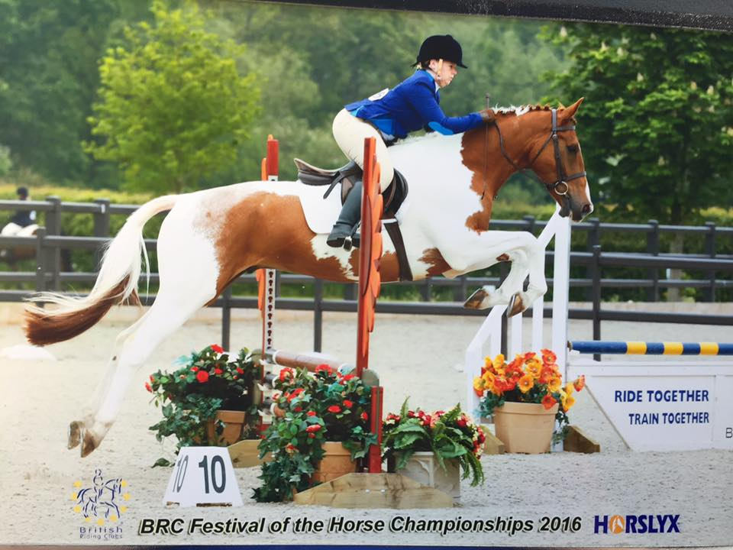

Jess Mace

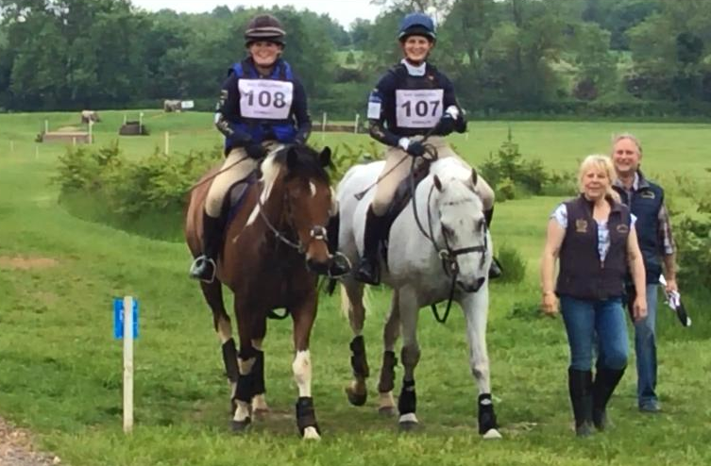

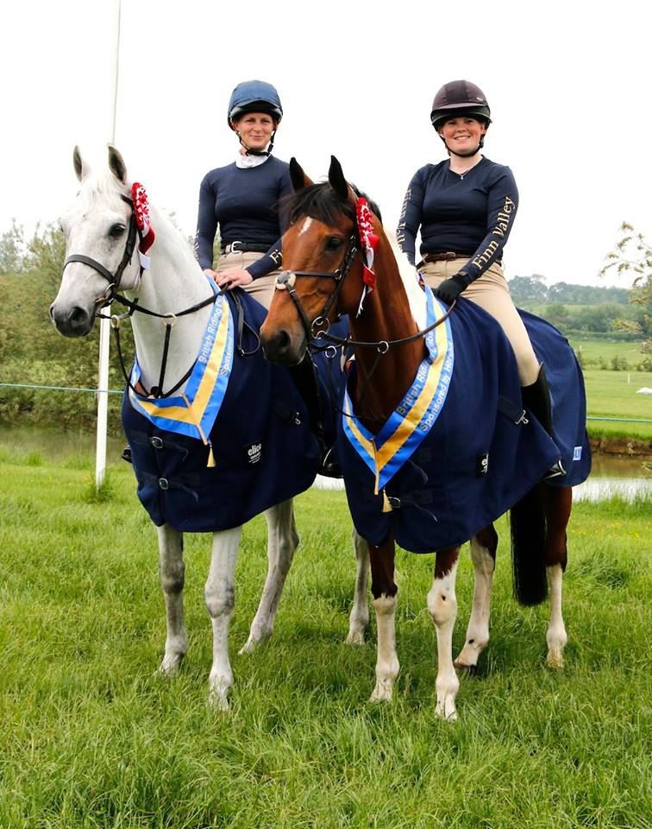

National Champions!

Rosie Stevens & Emma Sayer

